**St. Brigid St. John the Baptist**

**13th Sunday in**

**Ordinary Time**

**June 30, 2019**

**Catholic Church Catholic Church**

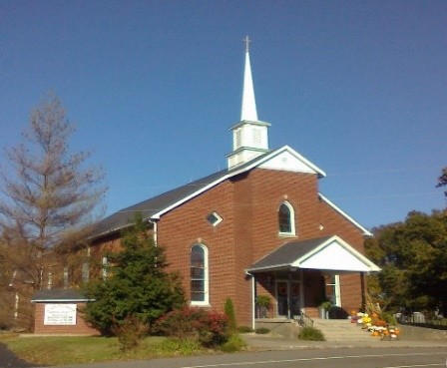

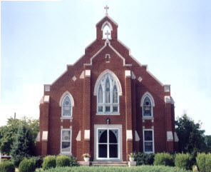



314 E. Main St. 657 St. John Church Rd.

Vine Grove, KY 40175 Elizabethtown, KY 42701

Clustered Parish Office: Clustered Parish Office:

(270) 877-2461 (270) 877-2461

**ANOINTING OF THE SICK:**

Notify the parish office when a family member is hospitalized.

**BAPTISM:**

Contact the parish office for information about the required preparation class.

**BULLETIN:**

Information must be submitted in writing by note or email to the parish office **no later than 4:00 p.m. on Tuesday** for the following weekend. When sending an email, please put “BULLETIN,” and the name of the parish the announcement is for, in the subject line.

**MARRIAGE:**

Contact Father at least 6 months prior to the wedding date to complete required marriage preparations and to schedule the date.

**RCIA (Rite of Christian Initiation of Adults):**

Contact the Worship Chairperson for information.

**DEW MEMORIAL LIBRARY:**

(in St. Brigid Church basement):

Open: Sunday after 9:30 a.m. Mass& 45 minutes before all other Masses.

Email: [brigidvg@bbtel.com](mailto:brigidvg@bbtel.com) Website: bit.ly/stjohnchurch

Website: [stbrigidvg.org](http://www.stbrigidvg.org)

**Pastoral Associate &** **Dir. of Religious Education:**

**Dir. of Religious Education:** Lisa Thomas: (270) 735-6930

Deacon Mike Ryan: (270) 877-0546

**Youth Ministers:**

**Youth Minister:**  Angela Churchman:

Lori Law: (270) 723-0157 (270) 268-9963

Ericka Finlay: (502) 612-2644

**MASS SCHEDULE:**

*Saturday (Vigil):*  6:30 p.m.

*Sunday:* 11:30 a.m.

*Wednesday:* 6:30 p.m.

*Friday:* 9:00 a.m.

**RECONCILIATION:**

Saturday before Mass

5:30-6:00 p.m. or by appt.

**PARISH COUNCIL MEMBERS:**

*President:* Lauran Thomas

*Secretary:* Clarissa Yates

**CHAIRPERSONS:**

*Administration:*  Nick Thomas

*Formation:* Ericka Finlay

*Parish Life:* Paul Taylor

*Worship:* Greg Thompson



**MASS SCHEDULE:**

*Sunday:* 9:30 a.m. & 6:30 p.m.

*Monday:* 9:00 a.m.

*Thursday:* 9:00 a.m.

**RECONCILIATION:**

Sunday before Mass

5:30-6:00 p.m. or by appt.

**ROSARY:**

After weekday Masses

**PARISH COUNCIL MEMBERS:**

*President:* Sue Weisshaupt

*Vice-President:* Mike Bramlett

*Secretary:* Judy Cochran

*At-Large Members:* Blake Ryan

& Jane Alder

**CHAIRPERSONS:**

*Administration:* Dale Winchester

*Formation:* Tina Yates

*Parish Life:* Tom Billings

*Worship:* Keith Baughman



|  |  |  |  |  |  |
| --- | --- | --- | --- | --- | --- |
| **Saturday** | **June 29** | **6:30 p.m.** | **St. John** | **For All Parishioners** | **Vigil: 13th Sunday in Ordinary Time** |
| **Sunday** | **June 30** | **9:30 a.m.** | **St. Brigid** | **Carlos Robbins**  **Emmett & Elmyra Harper** | **13th Sunday in Ordinary Time** |
| **“** | **“** | **11:30 a.m.** | **St. John** | **Bruce & Margaret Lincoln** | **“** |
| **“** | **“** | **6:30 p.m.** | **St. Brigid** | **Our Parish Family**  **James A. Smith** | **“** |
| **Monday** | **July 1** | **9:00 a.m.** | **St. Brigid** | **Elroy Rogers**  **Louise Stith** | **Weekday** |
| **Wednesday** | **July 3** | **6:30 p.m.** | **St. John** | **Tom & Kathryn Brangers**  **Judy Cleaver** | **St. Thomas, Apostle** |
| **Thursday** | **July 4** | **9:00 a.m.** | **St. Brigid** | **Clarence Jenkins** | **Weekday** |
| **Friday** | **July 5** | **9:00 a.m.** | **St. John** | **Joseph G. Greenwell** | **Weekday** |
| **Saturday** | **July 6** | **6:30 p.m.** | **St. John** | **Tom Brangers** | **Vigil: 14th Sunday in Ordinary Time** |
| **Sunday** | **July 7** | **9:30 a.m.** | **St. Brigid** | **Arthur R. Kieta**  **Bud & Pauline Brangers** | **14th Sunday in Ordinary Time** |
| **“** | **“** | **11:30 a.m.** | **St. John** | **For All Parishioners**  **Judy Cleaver** | **“** |
| **“** | **“** | **6:30 p.m.** | **St. Brigid** | **Ernie Heinen**  **Our Parish Family** | **“** |

**For Both Parishes**

**DANCE AT ST. MARTIN OF TOURS IN FLAHERTY, KY –** Gene Jones and Bent Penny Band will be here on **Saturday, July 20, 2019 from 7:00-10:00 p.m.** in the St Martin Gym.  Everyone is welcome!!! to join us and enjoy music from the #1 Rock ‘n Roll Band for two years in Lexington!  Food trucks will be available or you may bring your own snacks.  No alcohol please!  Everyone is welcome.  The cost will be a donation that will be used for archives, gym, and/ or buildings funds. See you there!

**VOCATIONS** – Do you know a young man or woman who might make a great priest, brother or sister? Help the Archdiocese of Louisville Vocations Office connect with them! By submitting names through our Called by Name initiative, you'll help us send potential discerners good information and invitations to discernment events. To participate visit: [www.louisvillevocations.com/called-by-name/](http://www.louisvillevocations.com/called-by-name/)

**PROJECT RACHEL** **–** Healing..Forgiveness..Hope. After the experience of an abortion. If you or someone you know is struggling with the pain from an abortion, please consider Project Rachel – a post abortion ministry. To speak to someone confidentially, email [ProjectRachel@archlou.org](mailto:ProjectRachel@archlou.org) or call (502) 471-2155.

**ABORTION** – Last month in Louisville, 303 babies were aborted. In 2019, a total of 1, 782 have been killed.

Pray for all concerned.

**CONFIDENTIAL PREGNANCY AND ADOPTION COUNSELING** – is available at Catholic Charities for women of all ages experiencing untimely pregnancies. A full range of services are provided, including adoptive placement, legal assistance and counseling for individuals, groups and families. Post-abortion counseling is also available. Services are provided regardless of income or marital status. For more information, call Catholic Charities at (502) 637-9786.

**St. John and St. Brigid Prayer List**

To add someone to the prayer list, please call the parish office at (270) 877-2461. **Remember to call to remove someone from the list if they are no longer sick, etc.** *Please note that the prayer list has been revised. It is primarily for parishioners and their immediate family members*.

Sam **Adams**, April **Allen**, Sidney **Anthony**, Dennis **Arnold**, Barbara **Ashley**, Donnie Alan **Atcher**, Shannon **Barnes,** Denise **Barnett**, Timothy **Birch**, Teresa **Blaycock**, Charlie **Bowers**, Ellen **Bryan**, Richard **Bryson**, Carol **Buchanan**, Linda **Buchanan**, Jeremy & Margie **Buyer**, Greg **Byerly**, Deacon Bob **Caspar**, Sue **Caswell**, Ed **Cecil**, J. Mack **Cecil**, Steve **Cecil**, John **Connor**, Betty Jo **Cooper**, Heidi **Correa**, Jeff **Craig**, Roan **Dowell**, Audrey **Durbin**, Karen **Dworshak**, Leroy **Embry**, Delphine **French**, Marion **French**, Dwayne **Garcia**, Carrie **Gribben**, Mary **Hager**, Mrs. Charles **Hair**, Stephanie **Hall**, Jimmy **Harper**, Bobby **Harris**, Eileen **Heinen**, Debbie **Hodge**, Finn **Johnson**, Betty Lou **Jones**, Betty Rose **Jones**, Charlene **Langley**, Jim **Lark**, Mary Colleen **Learned**, Connie **Leasor**, Olivia **Leasor**, Jenny **Leonhardt**, Jackie **Long**, Louise **Lucous**, Alma **Mahanna**, Shelly **Martin**, Shirley **Martin**, Martina **Masoni**, Don **Mattingly**, Gerard **Mattingly**, Paul Michael **Mattingly**, Mary **Medley,** Cindy **Miller**, Starla **Miller**, Doug **Osborne**, Duane **Osborne**, Mickey **Padgett**, Frank **Inanely**, Jerry **Phillips**, Annie **Pierce**, Adrianna **Porter**, Jeremy **Porter**, Mary Agnes **Ray**, Mary Ellen **Ray**, Tonya **Reisinger**, Joel **Rivera**, Suzanne **Russell**, Caroline **Seabee**, Karen **Shafffer,** Leon **Skeeters**, Ralph **Staples**, Keith **Tassin**, Kenny **Thompson**, Raffaella **Tucker**, Debi **Turner**, Stacey **Vance**, Tenley **Ward**, Bill **Waldrop**, Lois **Weaver**, De Neil **Whelan**, James **Whelan**, Paul A. **Whelan**, Jennifer **Williams**, Elizabeth Ann **Wiseman**, Sandy **Wiseman**, Zach **Wiseman**, Gail **Wilson**, Don **Wooldridge**, Connor **Wright**, and all the sick, both mentally and physically.

**OUR MILITARY List**

To add someone to the military list, please call the parish office at (270) 877-2461. **Remember to call to remove someone from the list if they are no longer in the service**.

LT. Matt **Bednar**, A1C Aaron **Chandler**, PFC Tyler **Hall**, A1C Ryan **Henley**, A1C Joseph **Manco**, SPC Jacob L. **Nall**, SFC Peter **Novak**, Tony **Rickerl**, James **Rogers**, Tony **Roger**s, Jonathon **Sifford**, Jeffrey **Slade**, Derek **Smith**, CSM Vance **Snider**, Brian **Tomassi**, A1C Daniel **Trombone**, SGT Evan **Wilson**, SSG Evan **Vaughan**, PFC William **Vaughan**, Mike **Veri**, Lisa **Veri**, SS Shelby Nicole **Winchester**, TSGT Jeremy **Yates**, Austin **Zulka** and for all who serve and have served our country.

**St. John The Baptist catholic church**

**Monthly Budget Amount Needed:** $ 12,500.00

**Monthly Collection for May:** $ 11,600.00

**Monthly Collection for June:** $ 11,005.25

**WELCOME PACKETS** – If you would like to become a member, or learn more about St. John Parish, please take a *Welcome Packet* in the church lobby. You may return the census card and the stewardship form to Father Dan or place in the collection basket.

**PARISH COUNCIL 2019-2020** – **President** – Lauran Thomas, **Secretary** – Clarissa Yates. **Worship** – Greg Thompson, **Formation** – Ericka Finlay, **Administration** – Nick Thomas and **Parish Life** – Paul Taylor.

**St. John liturgical ministers**

|  |  |
| --- | --- |
| **Vigil: 14th Sunday in Ordinary Time** | **July 6, 2019, 6:30 p.m.** |
| Extraordinary Ministers of the Eucharist | Leann Davidson Dennis Thomas Lori Shinault |
| Lector | Rhonda Newton |
| Servers | Claire Thomas Drew Thomas |
| Greeter(s) | Mary Hall |
| Gift Bearers | Ericka Finlay Angela Churchman |
| Ushers | Kevin Thomas Kenny Thompson |
| **14th Sunday in Ordinary Time** | **July 7, 2019, 11:30 a.m.** |
| Extraordinary Ministers of the Eucharist | Angela Thompson Jennifer Updegraff Scott Mattingly |
| Lector | Mary Ellen Williams |
| Servers | Jose Mariana Resto-Santos |
| Greeter(s) | Angela Churchman |
| Gift Bearers | Tim & Jennifer Wiseman |
| Ushers | David Yates Greg Thomas |
| **Hospital Minister – Sunday, July 28, 2019** | Martha Thomas Lauran Thomas |

**St. John youth ministry – RELIGIOUS EDUCATION**

For more information, contact Angela Churchman at (270) 268-9963 or Ericka Finlay: (502) 612-2644.

**St. Brigid catholic church**

**Monthly Budget Amount Needed:** $ 25,280.00

**Monthly Collection for May:** $ 25,361.05

**Monthly Collection for June:** $ 22,793.00

**WELCOME VISITORS** – If you are interested in joining our parish, please pick up a Welcome Packet at the church doors. Complete the registration form and either drop it in the collection basket or mail it to the office. If you just need to update your registration, there are also forms available.

**PRAYERS – Please keep Brandt-Evan Baker and Kara Atwell in your prayers as they prepare for the Sacrament of Marriage on July 6.**

**WE NEED YOUR HELP** – Do you know of any Catholics who are homebound and would like to receive Holy Communion on Sundays?  If you do, would you please notify the parish office, giving the person’s name and address.  We do not want anyone to feel neglected. Help us make sure we are trying to serve all Catholics.  The parish phone number is (270) 877-2461.

**EXTRAORDINARY MINISTERS OF THE EUCHARIST** – July through September 2019 EM schedules may be picked up at the back of the church. Also, Eucharistic Ministers, please sign-up to serve at Easter Masses at the back of the church. Thank you for your continued service to our parish.

**YOUNG AT HEART** – will meet **Wednesday, July 3**, for a potluck dinner. Games will start at 11:00 a.m. The dinner will start at 12:00 noon. The parish provides the chicken. Please bring a friend.

**ST. BRIGID YOUTH MINISTRY - SLIP & SLIDE PARTY!** **Friday, July 19, 6:00-8:00 p.m. in the CCC.** This parish-wide evening takes the place of the Family Game Night that was canceled on July 5 due to the holiday weekend. Join us in the CCC and on the back hill for a soapy, wet and fun slip & slide party. If sliding down a hill isn’t your thing then bring a folding chair and enjoy the show. You may want to bring water-friendly clothes or suit, shoes and a towel. We will have the rest taken care of including dinner and drinks! If you have any questions about this evening, please contact Lori Law at [stbrigidyouth@hotmail.com](mailto:stbrigidyouth@hotmail.com) or (270) 723-0157.

**SUMMER EVENT** – Exciting Summer Event News, **Sunday, September 8.**... This year FOUR CASH PRIZES WILL BE GIVEN AWAY. So, with one raffle ticket, you have four chances to win a cash prize. The cash amounts are $5000, $3000 and two $1000 prizes. Only 300 tickets are available. Tickets will be available for purchase starting this week from Deacon Mike Ryan. Ticket order forms will be available at the main office, Deacon Mike's office and at the doors of church next weekend. Get your ticket early to pick the numbered ticket of choice.

**OTHER SUMMER EVENT NEWS** – The delicious dinner will be catered by Two Taylor's from 12:30-2:30 p.m. Activities for children will be available from 12:00-3:00 p.m. as well as the Silent Auction bids. Keene and Company will be playing some great foot tapping/dance music. And another beautiful quilt will be raffled. If you would like to help with the Summer Event, please contact Deacon Mike at (270) 877-0546 or email at [mryan@bbtel.com](mailto:mryan@bbtel.com). We always can use extra help. God bless you for your gifts.

**ST. BRIGID CLASS OF 1969 REUNION**

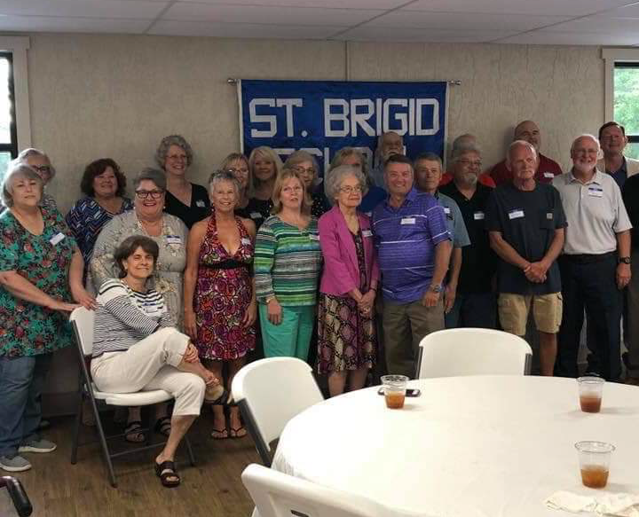

Classmates in attendance from left to right:

Theresa Whalen Winchester, Susie Sherrard, Charlotte Meredith,(in chair), Agatha Daugherty Perry, Helen Harper Hicks, Brenda French Henley, Judy Keith Spencer, Ruth Ray, Sherry Cowley Vivaldi, Gail Whelan Tassin, Gloria Rattizzi Ritter, Mrs. Martha Baughman, Pam Allen Marrelli, Chris Mayhew, Charles Ruley, Mark Skeeters, Mark Warnick, Mike Yates, Johnny Mattingly, Phillip Brangers, Bobby Brown, Larry Hawkins, and Kenneth Johnston.

On June 15, 2019 the St. Brigid 1969 graduating 8th grade class got together for a 50-year reunion. There were 22 former classmates in attendance along with their spouses or children with one very special guest, Mrs. Martha Baughman, one of their 6th grade teachers. The event was held at the newly renovated St. Brigid school cafeteria. It was a wonderful night filled with many stories, hugs, laughter and of course, precious memories.  Mrs. Baughman rang the original school bell for roll call. A moment of silence was held for deceased class members. Our many educators, most of whom where Ursuline nuns, as well as our lay teachers were fondly remembered through stories and memories.

**St. Brigid YOUTH MINISTRY**

**Wednesday , July 1** – Open Gym in the CCC for all youth in the 8th-12th grades from 6:30-8:30 p.m. Join other youth for fun, fellowship and an ice cream bar!

**Friday, July 19** – Slip & Slide Party from 6:00-8:00 p.m. in and behind the CCC. This evening is open to everyone so grab your family and friends, come out for dinner and a soapy slide down the hill.

**Sunday, July** 21 – Brunch at Bernheim after morning Mass. We will leave for Bernheim from the CCC after Mass and return at approximately 4:00. We will picnic, hike, pray, have some fun activities and free time to relax and enjoy nature.

If you have any questions, please contact Lori at (270) 723-0157 or [stbrigidyouth@hotmail.com](mailto:stbrigidyouth@hotmail.com)

**St. Brigid monthly meet and greet**



St. Brigid Parish hosts a “Meet and Greet” in the **School Cafeteria** the 2nd Sunday of each month immediately following the 9:30 a.m. Mass with coffee and donuts. This is a great opportunity for existing parishioners to extend a warm welcome to visitors and anyone interested in joining St. Brigid Parish. Be sure to also visit the Dew Memorial Library.

**The next Meet and Greet will be Sunday, July 14, 2019.**

**St. Brigid liturgical ministers**

|  |  |
| --- | --- |
| **14th Sunday in Ordinary Time** | **July 7, 2019, 9:30 a.m.** |
| Extraordinary Ministers of the Eucharist |  |
|  |  |
| Lector | John Jenkins |
| Servers | Molly Weisshaupt Tylar Craig |
| Gift Bearers | James Webb |
| Greeters |  |
| **14th Sunday in Ordinary Time** | **July 7, 2019, 6:30 p.m.** |
| Extraordinary Ministers of the Eucharist |  |
|  |  |
| Lector | Ron Masoni |
| Servers | Volunteers |
| Gift Bearers | Tim Cooper |
| Greeters |  |
| **Hospital Ministry – Sunday, July 14, 2019** | Sherleen & Ralph Barren |